Impact Evaluation Design for MCC

Rural Electrification Interventions in El Salvador

Elaborated by
Maximo Torero


Submitted to the
Millennium Challenge Corporation
MCC-07-0124-CON-91

by Social Impact, Inc.
October 24, 2009

Table of Contents

1. Background 3

2. Rural Electrification Program 4

3. Impacts of the rural electrification project 4

3.1. What we know as the impacts of rural electrification 4

3.2. What outcomes we expect as a result of the rural electrification project 5

4. Impact Evaluation Approach 8

4.1. First impact evaluation approach: non-experimental design taking advantage the timeline of the rollout of the project 9

4.2. Second impact evaluation approach: randomly assigned discount vouchers for the installation cost of the connection at the household 11

5. Sample design 14

6. Data collection 16

7. Timeline 17

8. References 18

Appendix 1: Sample Size and Power Calculation 19

Appendix 2: Calculation of the Number of Clusters per Condition for each of the Four Scenarios for the Variance 25

Appendix 3: Distributions 27

Appendix 4: Summary Tables for Other Outcome Variables: Number of clusters 28

Appendix 5: Summary Tables for Other Outcome Variables: Total Sample Size 29

Background

In November of 2006, the Millennium Challenge Corporation (MCC) signed a five-year, $461 million Compact with the Government of El Salvador (GOES) to improve the lives of Salvadorans through strategic investments in education, public services, agricultural production, rural business development, and transportation infrastructure. The Government of El Salvador has set up a management unit called FOMLIENIO to implement the 5 year Compact from September 2007 to September 2012. Social Impact has been contracted by MCC to conduct an impact evaluation of the rural electrification activity of the Compact.

The Rural Electrification activity of the El Salvador Compact will extend electricity to households in the Northern Zone that currently are not connected to local power distribution networks. Service will be provided to these households through, as appropriate for the household, investments in the extension of distribution networks, in individual household connections to the network, and in the supply of off-grid solar photovoltaic systems.

The impact evaluation seeks to determine the impact of electrification on the cost of energy, energy consumption, time allocation, and household income. Because the new electric lines will come from the existing power grid, an experimental design is not feasible for the overall impact evaluation. Therefore, the evaluators will combine two parallel approaches. The first approach to evaluate the overall impact of the project will use a non-experimental design taking advantage of the timeline of the rollout of the project and using propensity score matching to identify treatment (households that receive the new electrical service) and control groups (households that do not receive new service). Using specialized household surveys for both the household head and his/her spouse and with an intra-household time allocation module, the evaluators will estimate the differences in energy consumption, household income, and time use between the treatment and control groups. A difference-in-difference estimation method will control for changes in non-observable variables, and instrumental variables estimation will control for any remaining potential sources of selection bias.

The second approach will focus on the first set of households to be connected to the electricity grid, i.e. a subsample of towns and households from the full sample being evaluated. From this sub-sample of households we will select randomly an additional control and treatment group. The treatment group will be randomly assigned vouchers for 20% and 50% of the cost of the installation of the connection that the households/business will need to pay in order access the electricity once the cable reaches their household/business (the average cost is around 120 US$). Vouchers will be assigned randomly to 400 eligible survey respondents. The vouchers would not only encourage a sufficient level of demand for electricity access in the early stages of intervention, but would also provide a basis for experimental evaluation of accessibility to electricity by serving as an instrumental variable for electricity access. The randomly selected control towns and households will serve as an appropriate control group given that they will receive no vouchers.

This design report is divided in six further sections. In section 2 a brief description of the rural electrification project is presented; in section 3 the major outcomes to be evaluated are presented; in section 4 the impact evaluation approach is detailed; in section 5 the sample design required to implement the proposed impact evaluation designs is explained; in section 6 the data collection is described; and finally in section 7 the timeline of the impact evaluation design is explained.

Rural Electrification

The Rural Electrification activity of the El Salvador Compact will expand the electricity network to reach 47,000 households in the Northern Zone currently not connected, resulting in 97 percent coverage in this region. It is estimated that household income will increase by at least 15%. The project includes:
- Construction of approximately 1,500 km of new distribution lines and the corresponding connection of approximately 21,000 households to the expanded network;
- Connection of approximately 25,000 households to existing networks via the construction of necessary low voltage extensions; and
- Installation of approximately 950 solar power systems and provision of technical assistance for the creation of community associations for the management of solar power system operations and maintenance.

The impact evaluation will focus on evaluating the impact of (1) and (2), but will not include analysis of (3) – the solar power systems.

Table 1. Project Description
 | Expected number of beneficiaries | Expected Effects | Estimated Investment
Rural Electrification | 235,000 individuals/ | - Reduced expenditures on alternative energy sources  - Increase energy consumption | $33 million
 | 47,000 households | - It is expected that households will save 15% of their income

- The Impacts of the Rural Electrification Activity

3.1 What we know on the impacts of rural electrification

Rural areas of poor countries are often at a disadvantage in terms of access to electricity. The high cost of providing this service in remote, sparsely populated areas with difficult terrain and low consumption levels results in rural electricity schemes being more costly to implement than urban schemes. In addition, low rural incomes can lead to problems of affordability, and the long distances mean greater electricity losses and more expensive customer support and equipment maintenance. However, it has often been claimed that rural electrification has substantial welfare benefits, such as promoting production and better health and education outcomes for households. In a recent report by the Independent Evaluation Group (IEG) of the World Bank (2008), empirical support is found for many of these links and it is shown that rates of return on rural electrification projects are sufficient to warrant the investment. Moreover, it shows that consumer willingness to pay for electricity is almost always at or above supply cost.

Despite the findings reported in the IEG report, and as Esfahani and Ramirez (2003) point out, the estimates of the impacts of infrastructure access, and specifically rural electrification access, have been subject to numerous criticisms, which are fundamentally associated with endogenous problems and causality directions. Although access to infrastructure affects productivity, income, and economic growth, it also affects the supply and demand of infrastructure. By neglecting this simultaneity, there is a possibility of biasing estimated impacts.

Until very recently, the possibility of identifying causal relationships between access to electricity and its impacts on productivity or rural incomes was limited to macroeconomic studies based upon time series. These studies attempted to identify whether or not these investments precipitated the effects that are attributed to such investments. In recent years, however, with the development of evaluation methodologies (Rosenbaum and Rubin, 1983 or Heckman et al. 1998), advances have been made in establishing causal links from microeconomic evidence, comparing the trajectory of individuals subject to interventions, in relation to the trajectory of other comparable individuals that have not been subject to interventions (see for example IEG (2008), van de Walle (2003); Escobal et. al (2000) and Escobal and Torero (2004 and 2005). Moreover, recent work by Bernard and Torero (2009) has implemented a randomized evaluation of the impacts of rural electrification.

Because MCC’s rural electrification project in El Salvador included an impact evaluation strategy in its design, it offers a unique opportunity to identify these causal relationships. This is further detailed in the following section.

3.2 What outcomes we expect as a result of the rural electrification project

During the design phase of the rural electrification project, MCC and the Government of El Salvador developed an economic rate of return (ERR) model to compare the expected benefits and costs of the project. The main benefits in the model became the monitoring and evaluation indicators and will be the focus of the impact evaluation. They are the following:

- Household income/welfare
- Price of electricity per kilowatt-hour
- Consumption of electricity

Other outcomes were considered to be relevant, but not enough information was available to include them in the ERR model. Therefore, other outcomes will be analyzed through the impact evaluation in addition to the priority ERR indicators to try to understand the effects of providing electricity to rural Salvadoran households.

Rural electrification has been attributed a significant range of benefits as explained in IEG(2008), these can be summarized as follows:

- Income benefits because of access to electricity and therefore access to new opportunities of work, especially in nonfarm activities;
- benefits from lighting and TV/radio, mostly calculated by Willingness to Pay (WTP) as shown in IEG (2008);
- education benefits from higher educational attainment by the children of electrified households, which results in higher future earnings;
- time saved from household chores (additional leisure time), valued at the opportunity cost of labor, that is, the average wage, some evidence for Bangladesh and Peru can be found in Escobal and Torero (2004, 2005) and Chowdhury and Torero (2007);
- productivity of home business;
- increased agricultural productivity calculated as incremental revenue;
- improved health comes from the value of reduced mortality as a result of improved indoor air quality from reduced reliance on kerosene lamps;
- reduced fertility coming from knowledge from channels accessed using electricity, valued at the cost of achieving fertility reduction through reproductive health programs.
- public goods benefits, such as increased security (see for example Chowdhury and Torero 2007)

It would be too ambitious to try to capture all these benefits, identifying clearly the causal relationship, in the current evaluation. Instead, this impact evaluation of the El Salvador rural electrification project, tries to answer questions aimed at understanding the overall impact on socioeconomic development, namely:

- What is the impact of expanded access and use of electricity on household welfare?
- What is the impact of introducing energy efficient technology (i.e. connection to the grid vs other sources of off grid energy sources) on uses of electricity?

With that purpose we will concentrate on the following impact indicators:

- Indicators of changes in quality of the electricity service:

- Use of electricity
- Expenditure in electricity (proportion of total energy sources)
- Expenditure in electricity (proportion of total expenditure)
- Number of failures
- Price
- Sources of energy

- Indicators of changes in welfare:

As shown in Escobal and Torero (2004) household income can be represented as:
,

where Y is income approximated by expenditure, L is total household hours worked, Sl_{i} is the share of household working hours devoted to the i-th activity (where activities can be farm and non farm), y_{i}/l_{i} is the hourly wage in the i-th activity. Thus, changes in income can be represented as:

Assuming that interactions in the second row of the equation are negligible, changes in income can be approximated as:

This equation represents three of the possible channels through which income may be affected by access to electricity. On the one hand, the first component of the equation shows the impact of changes on the proportion of working hours allocated to different activities. In this particular case, we analyze shifts in labor devoted to agricultural and nonagricultural activities. Our hypothesis is that access to electricity leads to greater opportunities for nonfarm work activities. On the other hand, electricity may also create overall employment opportunities. Thus, the second component captures the effect of changes in the household’s total working hours. Finally, there is scope for increases in rural households’ market efficiency through increases in their purchasing power. In this line, the third component captures changes based on returns to labor (that is, hourly wages) allocated to agricultural and nonagricultural activities. Specifically in the case of agricultural activities this will be directly related to the prices of their products.

Therefore we proxy these impacts through the following indicators:

- Change in total income and expenditure
- Total hours of work – household
- Hours of work – household and individual
- % hours of non-ag work household and individual
- Hours spent on chores (specially collecting inputs for energy)
- Hours spent on childcare
- All above by gender

The expected effects from these outcomes are summarized in Table 2.

Table 2
Expected effects from the connectivity projects over major outcomes

- Impact Evaluation Approach

By conducting an impact evaluation of a given program, we intend to quantitatively estimate the change in the situation of the population due to the execution of the program. Thus we can compare the population’s situation given that the program has been executed relative to the population’s situation if the program had not been implemented. In other words the basic principle that guides our approach is the comparison between situations “with” the program and “without” the program, also known as “treatment effect” (following Figure 1 what must be determined in an impact assessment is the difference between A and B). This is as opposed to merely comparing “after” and “before” the program implementation (i.e. assessing the change in the situation of the beneficiary between before and after (comparing A to E) or the difference between participants and non-participants (A to D)). Unfortunately, it is not possible to observe state B, what would have occurred if the participant did not participate. (In Figure 1, the un-shaded boxes represent unobservable situations.)

Figure 1
Possible situations for treated and control households

Before the program

Treated

Controls

A: “Treatment” Status

B: “Non Treatment” Status

C: “Treatment” Status

D: “Non Treatment” Status

E:
Status before

F: Status before

Shaded boxes are

Observabl
e
situations

Uns
haded boxes are

Uno
bservabl
e

After the program

To address this problem, we need to identify a control group (D) that is as similar as possible to the treatment group, so that observations of D are a close approximation of B. The theoretically ideal approach to constructing a valid counterfactual is to use an experimental approach in which households are randomly assigned to treatment and control groups. Random assignment assures that the distributions of characteristics (both observed and unobserved characteristics) of the two groups are statistically indistinguishable. In our specific rural electrification program, and generally in the provision of infrastructure services, random assignment of non-treated communities is not feasible given that it could conflict with the deployment of the electrification lines.
Taking this into account, the proposed impact evaluation strategy combines two parallel approaches. The first approach to evaluate the overall impact of the project will use a non-experimental design taking advantage of the timeline of the rollout of the project and using propensity score matching to identify treatment (households that receive the new electrical service) and control groups (households that do not receive new service). Using a specialized household survey for both the household head and his/her spouse and with an intra-household time allocation module, the evaluators will estimate the differences in energy consumption, household income, and time use between the treatment and control groups. A difference-in-difference estimation method will control for changes in non-observable variables, and instrumental variables estimation will control for any remaining potential sources of selection bias.

The second approach will focus on the first set of households to be connected to the electricity grid, i.e. a sub-sample of towns and households from the full sample being evaluated. From this sub-sample of households we will select randomly an additional treatment group. The treatment group will be randomly assigned vouchers for 20% and 50% of the cost of installing the connection that the households/business will need to pay in order access the electricity once the cable reaches their household/business (the average costs are around 120 US$). Vouchers will be assigned randomly to 400 eligible survey respondents. The vouchers would not only encourage a sufficient level of demand for electricity access in the early stages of intervention, but would also provide a basis for experimental evaluation of accessibility to electricity by serving as an instrumental variable for electricity access. The randomly selected control towns and households will serve as an appropriate control group as they will receive no vouchers.

  - First impact evaluation approach: non-experimental design taking advantage the timeline of the rollout of the project

FOMOLENIO supplied, as shown in Figure 2, the first three phases of implementation. These phases are built based on the data already collected. In total, the project will likely cover 1,500 kilometers. Currently, the first three phases cover 600 kilometers. Fondo Salvadoreno para Estudios de Preinversion (FOSEP) will be then doing 500 additional kilometers and FOMILENIO 400 additional ones.

After several discussions with all the counterparts it was clear that the first 600km of pre design used to identify the projects of minimum costs were based on a study previously done. As a result, the first three phases are not prioritizing the minimum costs of intervention within the entire project area but only within those 600km. This could present some selection problems that we will need to take into account in our evaluation strategy. On the other hand, if we are not able to identify any major selection bias, this could also be in favor of the impact evaluation.

Figure 2
First three phases of implementation based on 600km of pre-design

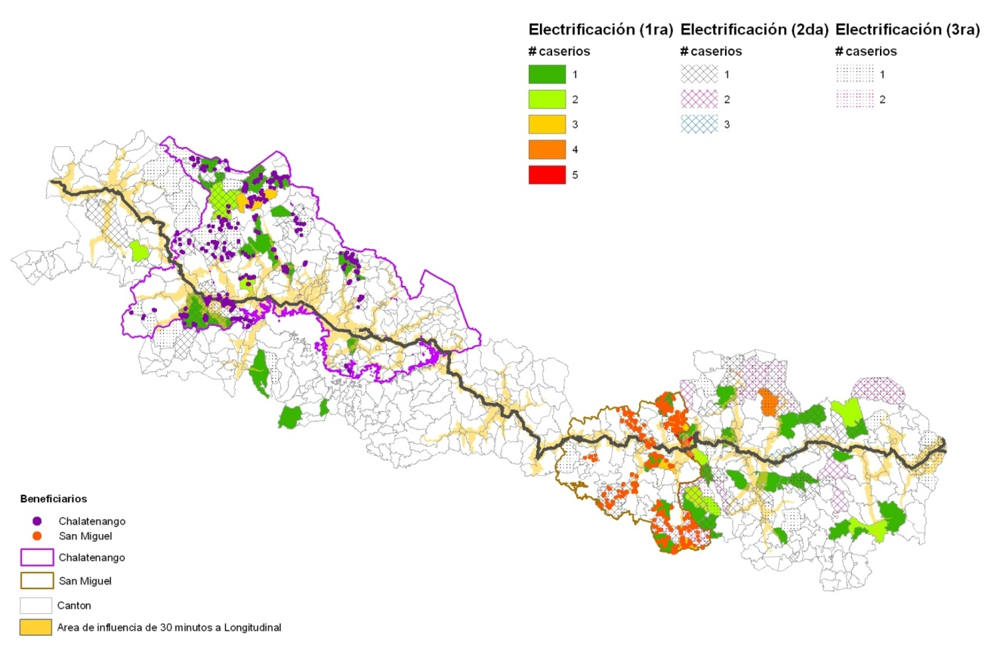

As a result, in this evaluation approach we will identify the treatment and control groups based on the phases of the intervention. Specifically, the households falling in Phase 1 (early phase of intervention) will be the treated households while the households falling in Phases 2-3 will be our potential control households. Based on this potential control group, we propose to use a combination of methods to obtain valid inferences about the household level impacts of the rural electrification programs. These include selecting our analytical samples of recipients and non-recipients to be as similar as possible in terms of their observable characteristics prior to the program. The framework serving as a guideline for our empirical analysis is the Roy-Rubin model (Roy 1951; Rubin 1974, 1977, 1979; Rosenbaum & Rubin 1983). Once propensity scores (predicted probabilities) have been computed for each of the households in the first survey sample, these scores will be used to select pairs of beneficiary and non-beneficiary households that are as similar as possible in terms of their propensity to be in the program.

Information on characteristics of potential survey households before the program initiation will be acquired from the baseline survey and this requires inclusion of as many questions as necessary to control for as many variables as possible. This information will be used to predict the propensity of being in the program using a binary probit model. In computing propensity scores, we also will use information from spatial (GIS) datasets for El Salvador and information from a community survey to take into account the agro-ecological conditions under which the households farm and their access to markets.

Although propensity score matching can ensure that treatment recipients are compared to non-recipients who are similar in terms of observable household characteristics, there still may be both observable and unobservable differences between recipients and non-recipients that may bias the results. For example, the quality and tenure of the plots used by recipients may differ from that of the non-recipients, and such information may not be available or usable for the propensity score matching and sample selection. This type of information will be added in the baseline surveys, and controlled for in the econometric analysis. Other explanatory variables collected in the survey will include household endowments of physical, human, natural, and financial capital, household access to markets, and services, and other factors influencing households’ livelihood options and outcomes.

Even after controlling for such observable differences, there may be differences in unobservable characteristics of recipients and non-recipients that can also bias the results (called “selection on unobservables” in the literature (Heckman, et al. 1998)). Two methods will be used to address this problem. First, some of the relevant unobservables may be relatively similar across households within a village (e.g., culture or trust level). Inclusion of village-level fixed effects in the econometric estimation can help to reduce any bias caused by such unobserved factors (Pitt and Khandker 1998).

Second, the double-difference (DD) estimator, which considers the difference between program participants and non-participants in changes in outcomes before and after the program ((A-E)-(D-F)) in Figure 1), will be used (this can be implemented in combination with an econometric approach controlling for differences between the participants and non-participants (Ravallion 2005)). Since we will have panel data collected, this method can be used based on differences in outcomes between the baseline and the follow-up survey. This approach removes the effects of any unobserved fixed factors that differ between participants and non-participants, if those have a linear additive impact on outcomes (e.g., differences in abilities). However, these results may be confounded by other changes between the time of the baseline and the follow-up survey besides the program influencing changes in outcomes differentially between participants and non-participants (e.g., changes in access to other programs). Changes in such other factors will be accounted for to the extent possible. However, there still may be biases caused by changing unobserved factors that differ between program treated and non-treated within villages (e.g., access to information). Instrumental variables (IV) estimation can be used to control for the remaining potential sources of selection bias.

For an IV estimation approach to be viable, we need to identify instrumental variables that are strong predictors of whether or not the household receives the access to rural electrification, but which can be validly excluded as direct determinants of the response or outcome of interest. It is likely to be difficult to identify suitable variables that meet these criteria although the exact timing of the connection (due more to technical reasons and not to an outcome variable) could potentially be a good instrument.

  - Second impact evaluation approach: randomly assigned discount vouchers for the installation cost of the connection at the household

The proposed evaluation design includes an innovative method for evaluating an important aspect of rural electrification: the installation cost that the households pay in order access the electricity once the cable reaches their household. Specifically, we propose randomly assigning vouchers of varying amounts that would help cover the fee for certifying that the house is ready to be connected. The vouchers will have two values: a 20 percent discount over the total certification costs (on average the total cost is around 120 US$) and a 50 percent discount. This innovation will only be applied to a subsample of the treatment households (400 households) during Phase 1. The remaining households will serve as an appropriate control group given they will receive no vouchers. In the event that vouchers proved to be poor predictors of individual electricity use but good predictors of community electricity use, this subpopulation could serve as a control group.

Voucher Implementation Design

We propose randomly assigning vouchers of varying amounts to encourage a sufficient level of demand for electricity access in the early stages of intervention, but also provide a basis for experimental evaluation of accessibility to electricity by serving as an instrumental variable (IV) for electricity use. In general, vouchers would be distributed in such a way to ensure that treatment and control groups are demographically representative within each of the possible treatment amounts.

The SI team would also randomly select a sub sample of towns from the pool of intervened towns to receive no vouchers. In the event that vouchers proved to be poor predictors of individual electricity use but good predictors of community electricity use, this subpopulation could serve as a control group.

Why is this random assignment of vouchers important?

Encouragements towards participation into the program are randomly allocated instead of limiting access to selected households. In such cases, program impact is identified via exogenous variations in the probability that one would decide to participate. As shown in (Imbens & Angrist, 1994) and (Angrist, Imbens, & Rubin, 1996) a Local Average Treatment Effect can be measured under a set of conditions. Based on this literature, encouragements studies have become increasingly popular. Recent studies based on such designs using either financial incentives or information campaigns (e.g. (Duflo & Saez, 2003), (Levine, Hema, & Ramage, July 2007), (Angrist, Bettinger, Bloom, King, & Kremer, 2002), (Kling, Ludwig, & Katz, 2005), (De Janvry, Sadoulet, & Villas Boas, January 2006)).

Indeed, encouragement-based designs such as the one we propose offer several advantages. First, they appear less exposed to critiques from an ethical perspective than their random program assignment counterparts, given that the program is not refused to anyone, only encouraged to some. Second, they are often directly relevant from a policy perspective. Such designs have for instance long been used to target subsidies towards nutrition (through food stamps), school (through vouchers for private schools), neighborhood relocation (through housing vouchers), and others. Third, they may be particularly appropriate to evaluate specific interventions such as infrastructure that are often non-excludable – and therefore difficult to evaluate in a traditional treatment / control setting – but whose impact is conditioned on their effective use – which can be encouraged.

Steps of Proposed Intervention

Household selection: the selected households to receive vouchers will come from a lottery to be implemented over the treatment and control households selected in the baseline survey. This selection will be a two step process: (a) first we randomly select treated and non-treated segments; and (b) secondly we randomly select households to receive vouchers within the selected segments and a random control group (no vouchers).

The selected households will receive the vouchers one month before the distribution of electricity is brought to the town and the vouchers will have a six-month duration.

FOMILENIO will directly provide their phone number in the voucher so that beneficiary households can directly contact them and then FOMILENIO will work with a contracted company that will certify the completion of the connection certification and approve the value of the vouchers.

Voucher Design

The vouchers are meant to assess the extent to which households are responsive to different levels of financial incentives for their decision to receive the electric connection. The effectiveness of vouchers in assessing such an effect relies on the random property of their allocation. Therefore, it was important to ensure that vouchers could not be sold, given or exchanged between the households, which would have otherwise led to potential selection biases in the analysis.

The voucher design will have been developed together with FOMILENIO with an official stamp from them, a unique serial number, a face value, and some instruction regarding its use. In addition, and to ensure that the random property of the allocation is preserved, the name of the household head to whom the voucher is allocated, as well as his/her address and national identity card number were to be written on the bottom of the voucher. The certified electricians can only accept the voucher from the person indicated in the voucher (see Figure 3 for the 20% voucher, the 50% voucher will be similar but with a different value).

Figure 3

Voucher Design – 50% discount (front)

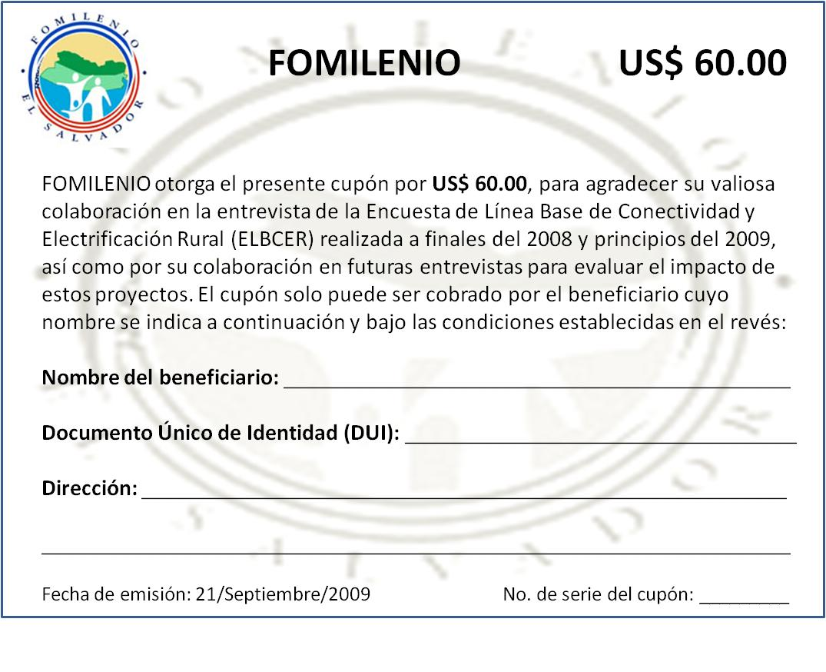

Voucher Design – 50% discount (back)

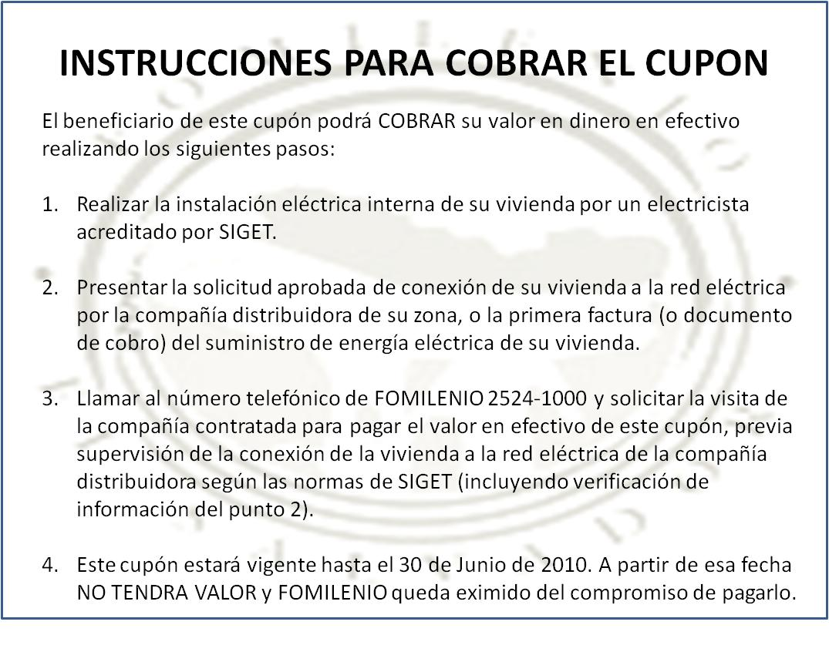

We recommend that two types of vouchers are designed: 20% discount and 50% discount, with the idea that the analysis will later compare response rates to no vouchers, 20% vouchers, and 50% vouchers to interpolate towards the level of an optimal subsidy. The value of the connection could range between 25 US$ to 120 US$, but it was agreed with FOMILENIO to use the 120 $ value. There will be four hundred vouchers distributed in selected areas where the beneficiary households of Phase 1 fall (see Figure 2 for details of specific location of Phase 1beneficiary households).

- The sample design

Conscious of budget limitations, we propose the study of only two departments, Chalatenango and San Miguel. These departments are proposed because, according to the current program plans (see Figure 2), they include the largest numbers of cantons that will benefit from the electrification program. In addition, these districts include a number of cantons that will be benefited from the road improvement and the electrification programs. Although rather modest, these districts will play a key role in the study of complementarities between road improvement and electrification.

We calculated the minimum sample size for each department following the same procedure of power calculation detailed in Appendix 1. In total we will require a total sample of 1,532 households; this is scenario 4 and clusters of 45 households. The results are presented in Table 2 and Figure 4. The resulting sample sizes for other variables are presented in Appendix 4 and 5.

Table 2. Number of Clusters per Condition¹ and Total Sample Size² for Household Income³ for each Scenario⁴
 |  | Scenario 1 |  | Scenario 2 |  | Scenario 3 |  | Scenario 4
 | Intracluster correlation⁶ | Clusters per condition | Total sample size | Clusters per condition | Total sample size | Clusters per condition | Total sample size | Clusters per condition | Total sample size
m=25⁵
Chalatenango | 0.030 | 41 | 2027 | 36 | 1824 | 20 | 1014 | 15 | 757
San Miguel | 0.073 | 96 | 4799 | 86 | 4319 | 48 | 2399 | 16 | 816
m=35
Chalatenango | 0.030 | 31 | 2147 | 28 | 1933 | 15 | 1074 | 11 | 744
San Miguel | 0.073 | 87 | 6060 | 78 | 5454 | 43 | 3030 | 11 | 802
m=45
Chalatenango | 0.030 | 25 | 2281 | 23 | 2053 | 13 | 1140 | 8 | 737
San Miguel | 0.073 | 81 | 7334 | 73 | 6600 | 41 | 3667 | 9 | 796
¹ The conditions are “treatment” and “control”. The number of clusters in each condition is equal
² Total sample size (treatment + control)
³ The outcome variable is total monthly household income
⁴ For the specification of each scenario see page 4, and for the formulae, see Appendix 1
⁵ Number of observations (households) per cluster
⁶ Observed in the NHS at the department level.
⁷ α=0.05; ß=0.20; =0.20
Figure 4
Sample required for the rural electrification project

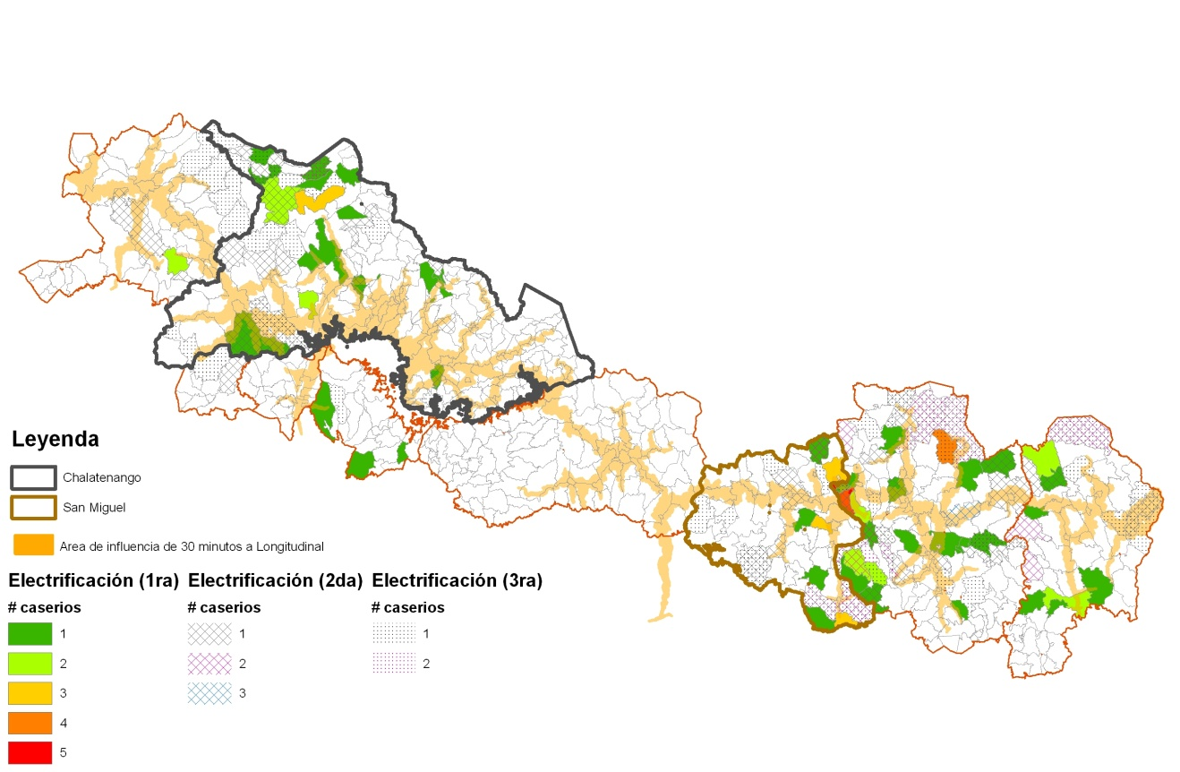

Note: Number of cacerios are the total number of cacerios sampled in the specific location where beneficiary households will fall in the different phases of electrification. Within each caserio households are randomly selected.

- Data collection

The evaluation will use household surveys and community surveys. To identify the households to be sampled, a census of the selected areas was implemented and a sample framework was developed which include a variable that identified if the household had access to electricity or not. From the sample framework a stratified random sample was selected within the household which did not have access to electricity at the moment of the pre-census.

The household survey will interview approximately 1,532 households as detailed in section 5. The questionnaire includes two sections – one that will be answered by the primary male household representative (including household income and agricultural productivity) and will be administered by a male enumerator, and the second which will be answered by the primary female representative in the household (including household demographics, time allocation, and expenses) and administered by a female enumerator. The survey has detailed sections for each of the outcomes to be evaluated, both intermediate and final outcomes. In addition, and to be able to control for accessibility to markets, each of the survey households was geo-referenced. If both persons are not present at the time of the first visit, enumerators will attempt to make an appointment and return again to interview the appropriate person, provided that this return visit is possible within the time that the survey team will be in the area. When possible, a second adult can also be included in the interview process, particularly for the questions related to work and agricultural output. The survey is designed to take between 1 and 1 ½ hours for each questionnaire (i.e. male and female).

The community survey will be applied to communities where selected households live. This survey will gather information about the local economy; price levels for food, basic commodities, and water and sanitation related expenditures; community infrastructure and access key markets and social services. The goal of the surveys is to provide some context for the information gathered in the household surveys, to track community-level changes that may affect outcomes, and to reduce the required length of the household survey questionnaire.

The current data collection plan anticipates that each household will be surveyed three times, 1) baseline in November 2008, 2) follow up in November 2010 and 3) final in November 2011. This may change however if there are delays in the construction schedule.

- Timeline

The timeline of the implementation of the design is described in Figure 6.

Figure 6

Timeline of Implementation

Follow up survey
11/10

M&E plan finalized
12/07
Final Evaluation report
5/12
Voucher implementation 09/09

Baseline data collection
11/08

Compact Ends
9/12
Entry into Force
9/07
Compact Signed
11/06

Final Survey Completed
11/11

Electricity connections scheduled to begin
Mid-2009

- References

General
Angrist, J., Imbens, G., & Rubin, D. (1996). Identification of causal effects using instrumental variables. Journal of the American Statistical Association , 91.
Angrist, J., Bettinger, E., Bloom, E., King, E., & Kremer, M. (2002). Vouchers for private schooling in Columbia: evidence from a randomized natural experiment. American Economic Review , 1535-1558.
De Janvry, A., Sadoulet, E., & Villas Boas, S. (January 2006). Short on shots: can self-restraint be effective in managing the scarcity of a vital good? University of California at Berkeley.
Duflo, E., & Saez, E. (2003). The role of information and social interactions in retirement plan decisions: evidence from a randomized experiment. Quarterly Journal of Economics, 118 (3), 815-842.
Escobal, Javier, & Torero, Maximo. (2005). Measuring the impact of asset complementarities: the case of rural Peru. Cuadernos de Economia 42. Pp. 1-26.

Heckman, J, H Ichimura, J Smith, & P Todd. 1998. Characterizing selection bias using experimental data. Econometrica. 66: 1017-99.
Kling, J., Ludwig, J., & Katz, L. (2005). Neighborhood effects on crime for female and male youth: evidence from a randomized housing voucher experiment. Quarterly Journal of Economics , 87-130.
Levine, D., Hema, N., & Ramage, I. (July 2007). Insuring health: testing for the effectiveness of micro-health insurance to promote economic wellbeing for the poor. BASIS brief no 2007-05.
Pitt, M & SR Khandker. 1998. “The impact of group-based credit programs on poor households in Bangladesh: does the gender of participants matter?” Journal of Political Economy. 106(5): 958-996.
Ravallion, M. 2005. Evaluating anti-poverty programs. World Bank Policy Research Working Paper 3625. The World Bank, Washington, D.C.
Rawlings, L.B. and N.R. Schady. 2002. Impact Evaluation of Social Funds: An Introduction. The World Bank Economic Review 16 (2): 213-217.
Rosenbaum, PR & DB Rubin. 1983. “The central role of the propensity score in observational studies for causal effects.” Biometrika. 70(1): 41-55.
Roy, A. 1951. "Some Thoughts on the Distribution of Earnings". Oxford Economic Papers. 3: 135-145.
Rubin, D. 1974. "Estimating Causal Effects to Treatments in Randomized and Nonrandomized Studies". Journal of Educational Psychology. 66: 688-701.
Rubin, D. 1977. "Assignment to Treatment Group on the Basis of a Covariate". Journal of Educational Studies. 2:1-26.
Rubin, D. 1979. "Using Multivariate Matched Sampling and Regression Adjustment to Control Bias in Observational Studies". Journal of the American Statistical Association. 74: 318-328.

Electricity

Bernard, Tanguy and Torero, Maximo. 2009. Randomizing the ‘last mile’ A note on using vouchers to assess householdlevel impact of rural electrification. IFPRI, Washington D,C.

Chowdhury, Shyamal and Torero, Maximo. 2007. Impact of infrastructure on income and work of rural households, women and the landless in the Northwestern Region of Bangladesh, IFPRI, Washington DC.

Escobal, Javier, and Torero, Maximo 2004. “Análisis de los Servicios de Infrastructura Rural y las Condiciones de Vida en las Zonas Rurales del Perú. GRADE mimeo.

Escobal, Javier, and Torero, Maximo. 2005. Measuring the impact of asset complementarities: the case of rural Peru. 2005. Cuadernos de Economia 42. Pp. 1-26.

IEG-World Bank, -IFC. 2003. Power for Development: A Review of the World Bank Group’s Experience with Private Participation in the Electricity Sector. IEG Study Series. Washington, DC: World Bank.

IEG. 2009. The Welfare Impacts of Rural Electrification: A Reassessment of the Costs and Benefits. An IEG Impact Evalution. World Bank, Washington D.C.

Bamberger, Michael and Eleanor Hewitt. 1986. “Monitoring and Evaluating Urban Development Programs: A Handbook for Program Managers and Researchers.” World Bank Technical Paper No. 53. Washington, D.C.

Ghafur, Shayer. 2001. “Beyond homemaking: the role of slum improvement in home based income generation in Bangladesh.” Third World Planning Review 23(2): 111-135.

Imparato, Ivo and Jeff Ruster. 2003. “Slum upgrading and participation: Lessons from Latin America.” Directions in Development Series. Washington, D.C.: World Bank.

Dominique van de Walle, 2003. "Are Returns to Investment Lower for the Poor? Human and Physical Capital Interactions in Rural Vietnam," Review of Development Economics, Blackwell Publishing, vol. 7(4), pages 636-653, November

Appendix 1
Sample Size and Power Calculation

1. Introduction

With the objective of studying the effect of rural electrification program in San Miguel and Chalatenango, 1,533 observations are needed. Due to the high intracluster correlations observed in variables as non-agricultural waged income or time allocated to non-agricultural non-wage labor, the power to detect differences in such variables will be lower, although it may still be possible to detect differences.

Section 2 deals with survey design issues like the intracluster correlation and assumptions in the variance calculation. Section 3 covers the main issues regarding power calculation when the treatment is discrete as it is in the rural electrification project. Section 4 discusses the sample size requirements to assess the rural electrification programs. Section 6 summarizes the findings and recommends specific sample size.

2. Survey Design

We assumed a clustered, quasi-randomized evaluation design with treatments administered at the cluster level and data collection before and after initiation of the treatments. With this design, impact estimates can be measured using the preferred approach of taking difference-in-differences or “double difference”: the change in the outcome in the treatment group minus the change in the outcome in the quasi-randomized control (or alternate treatment) group. The purpose of the sample size estimates is to determine the minimum impact,, that can be detected for a given number of sampled clusters, g, and households per cluster, m, in each treatment for the evaluation sample. If the impact of the treatment is at least as large as, we will be able to detect it 80 percent of the time in a sample of total size mg. If the treatment impact is less than, we are less likely to detect it, although it is still possible.

3. Intracluster Correlation

The most controversial issue in sample design is the intracluster correlation, so we will proceed to make the calculation procedure explicit. DIGESTYC provided detailed GIS data on the location of all the dwellings that will be electrified in the northern El Salvador. In an ideal scenario, we would have the relevant socio-economic data from the census as well, but at the time of writing this was not available. The intracluster correlation of several variables (was calculated from the EPHM Survey 2007). Merging the survey and the GIS data, the cantons that will be electrified were identified and matched to the household survey data. The universe is constituted by the set of cantons that were identified. The sub-set of cantons that were also included in the household survey constitutes “level 1”.

For those cantons that were not included in the NHS survey, the municipality income and time allocation data was imputed. This group plus “level 1” constitutes “level 2”. In turn, for those municipalities that were not included in the survey, the department data was imputed. These sub-set plus “level 2” conforms “level 3”.

Several outcome variables were used in the analysis. We will summarize the results for overall household income, but the analysis also included weekly working hours, and both split by wage agriculture, non-wage agriculture, wage non-agriculture, and non-wage non-agriculture.

4. Scenarios for Variance Calculation
There are three important differences between the proposed sample for evaluation and the NHS sample, all of which are likely to affect the sample variance in the projected sample relative to that in the NHS sample: First, we estimate variance of the primary outcomes in the NHS using only one round of data collection, rather than two. The variance of the difference between the two measures depends upon the variance of each measure as well as the correlation over time between the two measures. We do not know this correlation; so we must make assumptions about it, which we vary below. Second, we stratified the sample for the collection of this data, in order to both balance the sample and reduce the sampling variance. The reduction in sampling variance will depend upon the variance between strata means; the larger the difference between the average outcomes across strata, the higher the variance reduction will be. Third, the NHS measures the variance of outcomes related to different levels of current access to roads; it is likely that the variance of baseline will be smaller given the assumptions of accessibility we are imposing.
Since the three differences between the proposed surveys and the NHS will certainly affect the variance of primary outcomes, we experiment with power calculations using several different variance estimates. First and most conservatively, we simply double the variance of the NHS outcomes; doing so assumes that the primary outcome will not be correlated across the two surveys, that each strata will have exactly the same mean outcome, and that the treatment will not affect the variance of the treatment. Second, we reduce the doubled variance by 10 percent, to simulate a significant decline in sample variance due to stratification. Third, we simply compute the power calculations using the NHS variance. Finally, we use the NHS variance less 10 percent, to account for gains from stratification, but also assume between-period correlation of 0.5 and a within-period correlation of -0.5. Since we also ignore the above assertion that the baseline variance in outcomes is likely to be smaller than the NHS variance, the fourth estimate is likely to be the most realistic and the one we propose to use.

5. Power calculations

Discrete Treatment

The impact evaluation will be conducted with difference-in-difference estimators. This methodology requires repeat observations on members. Power calculations for this type of survey designs were based on Murray (1998, chapter 9). The main analysis is based on the following three equations (the equation number in Murray’s book is in brackets):

…(1) [9.23]
…(2) [9.17]

…(3) [9.34]

Where:
g: number of clusters in each condition (treatment/control)
m: number of observations per cluster
ICC: Intracluster correlation
α: type I error rate
ß: type II error rate
: estimated variance of the outcome variable
: estimated change
: estimated variance of the change in the outcome variable
r_{yy(g)}: inter-period correlation
r_{yy(m)}: intra-period correlation

Replacing (2) in (1), we get:

…(4)
Inserting (3) in (4):

… (5)
Solving for g:

…(6)

6. Summary of sample size needed to measure the impact of the rural electrification program

Conscious of budget limitations, we propose the study of only two departments, Chalatenango and San Miguel for studying the impact of the rural electrification program. These departments are proposed because, according to the current program plans, they include the largest numbers of cantons that will benefit from the electrification program. In addition, these districts include a number of cantons that will be benefited from the road improvement and the electrification programs. Although rather modest, these districts will play a key role in the study of complementarities between road improvement and electrification.

Following the procedure as in section 5 we calculate the minimum sample size for each department. The results are presented in Table A.1. We recommend Scenario 4 given the main assumptions are Type I and II error rates of 5% and 20% respectively and a change in incomes of at least 20% under a discrete treatment.

Table A.1. Number of Clusters per Condition¹ and Total Sample Size² for Household Income³ for each Scenario⁴
 |  | Scenario 1 |  | Scenario 2 |  | Scenario 3 |  | Scenario 4
 | Intracluster correlation⁶ | Clusters per condition | Total sample size | Clusters per condition | Total sample size | Clusters per condition | Total sample size | Clusters per condition | Total sample size
m=25⁵
Chalatenango | 0.030 | 41 | 2027 | 36 | 1824 | 20 | 1014 | 15 | 757
San Miguel | 0.073 | 96 | 4799 | 86 | 4319 | 48 | 2399 | 16 | 816
m=35
Chalatenango | 0.030 | 31 | 2147 | 28 | 1933 | 15 | 1074 | 11 | 744
San Miguel | 0.073 | 87 | 6060 | 78 | 5454 | 43 | 3030 | 11 | 802
m=45
Chalatenango | 0.030 | 25 | 2281 | 23 | 2053 | 13 | 1140 | 8 | 737
San Miguel | 0.073 | 81 | 7334 | 73 | 6600 | 41 | 3667 | 9 | 796
¹ The conditions are “treatment” and “control”. The number of clusters in each condition is equal
² Total sample size (treatment + control)
³ The outcome variable is total monthly household income
⁴ For the specification of each scenario see section 3.2, and for the formulae, see Appendix 2 and 2.
⁵ Number of observations (households) per cluster
⁶ Observed in the NHS at the department level.
⁷ α=0.05; ß=0.20; =0.20

Appendix References

Behrman, J., Y. Chen and P. Todd (2004) “Evaluating Preschool Programs When Length of Exposure to the Program Varies: A Nonparametric Approach” Review of Economics and Statistics 86: 108-132.

Hirano, K., and G. Imbens (2004) “The Propensity Score with Continuous Treatments” in A. Gelman and X. Meng (eds.), Applied Bayesian Modeling and Causal Inference from Incomlpete-Data Perspectives, Wiley.

Imai, K, and D. van Dyk (2004) “Causal Inference with General Treatment Regimes: Generalizing the Propensity Score” Journal of the American Statistical Association 99: 854-866.

Imbens, G. (2000) “The Role of the Propensity Score in Estimating Dose-Response Functions”, Biometrika 87: 706-710.

Murray, D. (1998) Design and Analysis of Group-Randomized Trials. New York and Oxford: Oxford University Press.

Appendix 2

Calculation of the Number of Clusters per Condition for each of the Four Scenarios for the Variance

Scenario 1:
Double the NHS variance

Scenario 2:
Reduce the doubled NHS variance by 10%

Scenario 3:
Use the NHS variance

Scenario 4:
Reduce the NHS variance by 10%, and assume between-period correlation of -0.5 and inter-period correlation of 0.5

Using equations (2) and (3), we may express as

With this,

Cancelling out and solving for g we finally get

This way we can include the assumptions about the within- and between-period correlations (-0.5 and 0.5, respectively). With this, the final formula for the number of clusters per condition in scenario 4 is

Appendix 3

Distributions

TheDistribution
If , then the random variable.

The Non-central Distribution

The non-central distribution is a generalization of the distribution. If , then the random variable, where is the non-central chi-squared distribution with non-centrality parameter defined as.

The Non-central F Distribution

If , , and X_{i} and Y_{i} are statistically independent, then

, where is the non-central F distribution with non-centrality parameter defined as.

Appendix 4

Summary Tables for Other Outcome Variables: Number of clusters (discrete treatment)
 | 25 observations per cluster |  |  |  |  | 35 observations per cluster |  |  |  |  | 45 observations per cluster
 | 1 | 2 | 3 | 4 |  | 1 | 2 | 3 | 4 |  | 1 | 2 | 3 | 4
Chalatenango
total income | 41 | 36 | 20 | 15 |  | 31 | 28 | 15 | 11 |  | 25 | 23 | 13 | 8
wage agr inc | 19 | 17 | 10 | 9 |  | 13 | 12 | 7 | 6 |  | 10 | 9 | 5 | 5
non wage ag inc | 33 | 30 | 17 | 9 |  | 28 | 25 | 14 | 6 |  | 25 | 22 | 12 | 5
wage non ag inc | 10 | 9 | 5 | 5 |  | 7 | 7 | 4 | 3 |  | 6 | 5 | 3 | 3
non wage non ag inc | 36 | 33 | 18 | 8 |  | 31 | 28 | 16 | 6 |  | 29 | 26 | 14 | 5
total hours hrs | 27 | 24 | 13 | 10 |  | 21 | 18 | 10 | 7 |  | 17 | 15 | 9 | 5
wage agr inc hrs | 108 | 97 | 54 | 51 |  | 76 | 68 | 38 | 36 |  | 59 | 53 | 29 | 28
wage non ag hrs | 94 | 84 | 47 | 22 |  | 80 | 72 | 40 | 15 |  | 73 | 66 | 37 | 12
non wage ag hrs | 307 | 276 | 153 | 37 |  | 288 | 259 | 144 | 26 |  | 277 | 250 | 139 | 20
non wage non ag hrs | 138 | 124 | 69 | 64 |  | 97 | 87 | 49 | 45 |  | 75 | 67 | 37 | 35
San Miguel
total income | 96 | 86 | 48 | 16 |  | 87 | 78 | 43 | 11 |  | 81 | 73 | 41 | 9
wage agr inc | 25 | 23 | 13 | 9 |  | 19 | 17 | 10 | 6 |  | 16 | 15 | 8 | 5
non wage ag inc | 48 | 43 | 24 | 10 |  | 41 | 37 | 21 | 7 |  | 38 | 34 | 19 | 6
wage non ag inc | 14 | 13 | 7 | 7 |  | 10 | 9 | 5 | 5 |  | 8 | 7 | 4 | 4
non wage non ag inc | 23 | 21 | 12 | 6 |  | 19 | 17 | 10 | 4 |  | 17 | 16 | 9 | 3
total hours hrs | 15 | 13 | 7 | 7 |  | 10 | 9 | 5 | 5 |  | 8 | 7 | 4 | 4
wage agr inc hrs | 57 | 52 | 29 | 26 |  | 40 | 36 | 20 | 18 |  | 31 | 28 | 15 | 14
wage non ag hrs | 137 | 123 | 69 | 63 |  | 96 | 87 | 48 | 44 |  | 74 | 67 | 37 | 34
non wage ag hrs | 107 | 96 | 53 | 18 |  | 96 | 87 | 48 | 13 |  | 90 | 81 | 45 | 10
non wage non ag hrs | 420 | 378 | 210 | 100 |  | 359 | 323 | 179 | 70 |  | 326 | 293 | 163 | 54

Appendix 5
Summary Tables for Other Outcome Variables: Total Sample Size (discrete treatment)
 | 25 observations per cluster |  |  |  |  | 35 observations per cluster |  |  |  |  | 45 observations per cluster
 | 1 | 2 | 3 | 4 |  | 1 | 2 | 3 | 4 |  | 1 | 2 | 3 | 4
Chalatenango
total income | 1014 | 912 | 507 | 379 |  | 1074 | 966 | 537 | 372 |  | 1140 | 1026 | 570 | 369
wage agr inc | 477 | 429 | 238 | 216 |  | 469 | 422 | 234 | 213 |  | 464 | 418 | 232 | 211
non wage ag inc | 830 | 747 | 415 | 215 |  | 974 | 877 | 487 | 211 |  | 1122 | 1010 | 561 | 209
wage non ag inc | 258 | 232 | 129 | 119 |  | 253 | 228 | 127 | 117 |  | 251 | 226 | 126 | 116
non wage non ag inc | 910 | 819 | 455 | 208 |  | 1095 | 986 | 548 | 205 |  | 1284 | 1155 | 642 | 203
total hours hrs | 673 | 606 | 337 | 246 |  | 718 | 646 | 359 | 242 |  | 767 | 690 | 383 | 240
wage agr inc hrs | 2706 | 2435 | 1353 | 1274 |  | 2659 | 2393 | 1330 | 1252 |  | 2634 | 2371 | 1317 | 1240
wage non ag hrs | 2347 | 2112 | 1173 | 546 |  | 2816 | 2534 | 1408 | 536 |  | 3294 | 2965 | 1647 | 531
non wage ag hrs | 7672 | 6905 | 3836 | 922 |  | 10071 | 9064 | 5035 | 906 |  | 12484 | 11236 | 6242 | 897
non wage non ag hrs | 3455 | 3109 | 1727 | 1609 |  | 3395 | 3056 | 1698 | 1582 |  | 3364 | 3027 | 1682 | 1567
San Miguel
total income | 2399 | 2159 | 1200 | 408 |  | 3030 | 2727 | 1515 | 401 |  | 3667 | 3300 | 1833 | 397
wage agr inc | 627 | 565 | 314 | 223 |  | 676 | 608 | 338 | 220 |  | 728 | 655 | 364 | 217
non wage ag inc | 1191 | 1072 | 595 | 259 |  | 1447 | 1302 | 724 | 254 |  | 1708 | 1537 | 854 | 252
wage non ag inc | 361 | 325 | 180 | 163 |  | 354 | 319 | 177 | 160 |  | 351 | 316 | 176 | 159
non wage non ag inc | 579 | 521 | 289 | 151 |  | 678 | 610 | 339 | 149 |  | 779 | 701 | 390 | 147
total hours hrs | 371 | 334 | 185 | 168 |  | 364 | 328 | 182 | 166 |  | 361 | 325 | 181 | 164
wage agr inc hrs | 1433 | 1289 | 716 | 656 |  | 1408 | 1267 | 704 | 645 |  | 1395 | 1255 | 697 | 639
wage non ag hrs | 3426 | 3083 | 1713 | 1565 |  | 3367 | 3030 | 1684 | 1538 |  | 3335 | 3002 | 1668 | 1524
non wage ag hrs | 2663 | 2397 | 1331 | 451 |  | 3364 | 3028 | 1682 | 444 |  | 4072 | 3665 | 2036 | 440
non wage non ag hrs | 10506 | 9455 | 5253 | 2495 |  | 12556 | 11301 | 6278 | 2452 |  | 14650 | 13185 | 7325 | 2429

Maximo Torero is Division Director of the Markets, Trade and Institutions Division at the International Food Policy Research Institute (IFPRI), email: m.torero@cgiar.org
The impact evaluation does not include evaluation of the solar photovoltaic systems.
This figures will be updated with the new Census Data availability, FOMILENIO will be providing this new information.
However, where electricity replaces other commercial fuels, such as kerosene, households’ energy costs may fall rather than rise.
This would occur if a competitive underground market for vouchers emerged.
The three scenarios refer to the variance used for the outcomes. First and most conservatively, we simply double the variance of the national household survey (NHS) outcomes; doing so assumes that the primary outcome will not be correlated across the two surveys, that each strata will have exactly the same mean outcome, and that the treatment will not affect the variance of the treatment. Second, we reduce the doubled variance by 10 percent, to simulate a significant decline in sample variance due to stratification. Third, we simply compute the power calculations using the NHS variance. Finally, we use the NHS variance less 10 percent, to account for gains from stratification, but also assume between-period correlation of 0.5 and a within-period correlation of -0.5. Since we also ignore the above assertion that the baseline variance in outcomes is likely to be smaller than the NHS variance, the fourth estimate is likely to be the most realistic and the one we propose to use.
For details on sample selection see sample selection final report.
In addition to g and m, the minimum detectable impact, , is a function of the variance of the outcome variable, its intracluster correlation, and the area of influence of the highway being evaluated.
The degrees of freedom for all the t statistics in every scenario are given by df = 2(g-1)
These tables make the same assumptions as Table A.1.
These tables make the same assumptions as Table A.1.

